

MATHEMATICS
Specialist Units 3 & 4

Test 4 – Integration

Chapters 13, 14 and 15
Semester 2 2017

Section Two – Calculator Assumed

Time allowed for this section
Working time for this section: 20 minutes
Marks available: 20 marks

Material required/recommended for this section

To be provided by the supervisor
This Question/Answer booklet
Formula sheet

To be provided by the candidate
Standard items: pens, pencils, pencil sharpener, eraser, correction fluid, ruler, highlighters

Special items: drawing instruments, templates, notes on one unfolded sheet of A4 paper, and up to three calculators satisfying the conditions set by the Curriculum Council for this course.

Important note to candidates
No other items may be used in this section of the examination. It is your responsibility to ensure that you do not have any unauthorised notes or other items of a non-personal nature in the examination room. If you have any unauthorised material with you, hand it to the supervisor before reading any further.

- (4 marks)
The area enclosed by the x-axis, the lines $x=1$ and $x=4$ and the curve $y=1+\sqrt{x}$ is rotated $360°$ about the x-axis. Calculate the volume of the solid generated to an accuracy of two decimal places.

- (6 marks)
- Find $\int{\frac{5x^{2}-10x-3}{(x+1){(x-1)}^{2}}}$ $dx$ using partial fractions. [3]

- Hence express $\int_{2}^{5}{\frac{5x^{2}-10x-3}{(x+1){(x-1)}^{2}}}$ $dx$ as a single logarithm. [3]

x | f(x)
3.0 | 2.87
3.2 | 2.90
3.4 | 2.94
3.6 | 2.97
3.8 | 3.00
4.0 | 3.04
4.2 | 3.08
4.4 | 3.12
4.6 | 3.16
4.8 | 3.20
5.0 | 3.25
5.2 | 3.30
5.4 | 3.36
5.6 | 3.42
5.8 | 3.49
6.0 | 3.56
6.2 | 3.64
6.4 | 3.73
6.6 | 3.82
6.8 | 3.92
7.0 | 4.03
- (10 marks)
Consider the region enclosed by the curve $y=f\left(x\right), x=3, x=7$ and the $x$ axis.
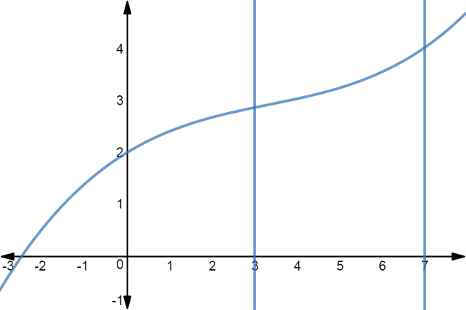
y

x

The accompanying table shows the value of the function $f(x)$ for
various values of $x, 3≤x≤7.$

The value of the area of this region is $\int_{3}^{7}{f\left(x\right)dx}$ which may be approximated using the Trapezoidal rule:

$$\int_{a}^{b}{f\left(x\right)dx≈\frac{1}{2}}w(y_{0}+2y_{1}+2y_{2}+…+2y_{n-1}+y_{n})$$

or using Simpson’s rule:

$\int_{a}^{b}{f\left(x\right)dx≈\frac{1}{3}}w(y_{0}+4y_{1}+2y_{2}+4y_{3}+2y_{4}…+2y_{n-2}+4y_{n-1}+y_{n})$

where, in each case, $y_{0}=f\left(x_{0}\right)=f\left(a\right), y_{n}=f\left(x_{n}\right)=f(b)$ and $w=$ $\frac{b-a}{n}$

- Use Simpson’s rule over 4 intervals to approximate $\int_{3}^{7}{f\left(x\right)dx}$ [3]

- Use the Trapezoidal rule over 5 intervals to approximate $\int_{3}^{7}{f\left(x\right)dx}$ [3]

- For $y=f(x)$ the following sums were determined

$\sum_{i=1}^{9}{y_{2i}}$ $=29.73$ and $\sum_{i=1}^{10}{y_{2i-1}}$ $=33.16$

Use these sums and Simpson’s rule over 20 intervals to estimate the area of the region. [4]

End of Section Two
This page has intentionally been left blank
You may use this space to extend or re-attempt an answer to a question or questions and should you do so then number the question(s) attempted and cross out any previous unwanted working.

